Erdem Helvacıoğlu & Ros Bandt - Black Falcon (2011)
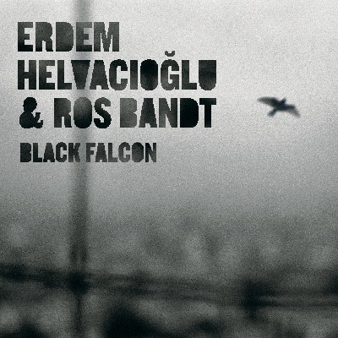
1.The Black Falcon
2.Falconer's Knot
3.Game Country
4.Circle Around The Shadows
5.Flow Of Victory
6.Moment Of Delicacy
7.Returning Home

